**Azure Api Management**

1. In Azure portal we get Api Management services in search box also we search and get then we need to click on create + to create api management services

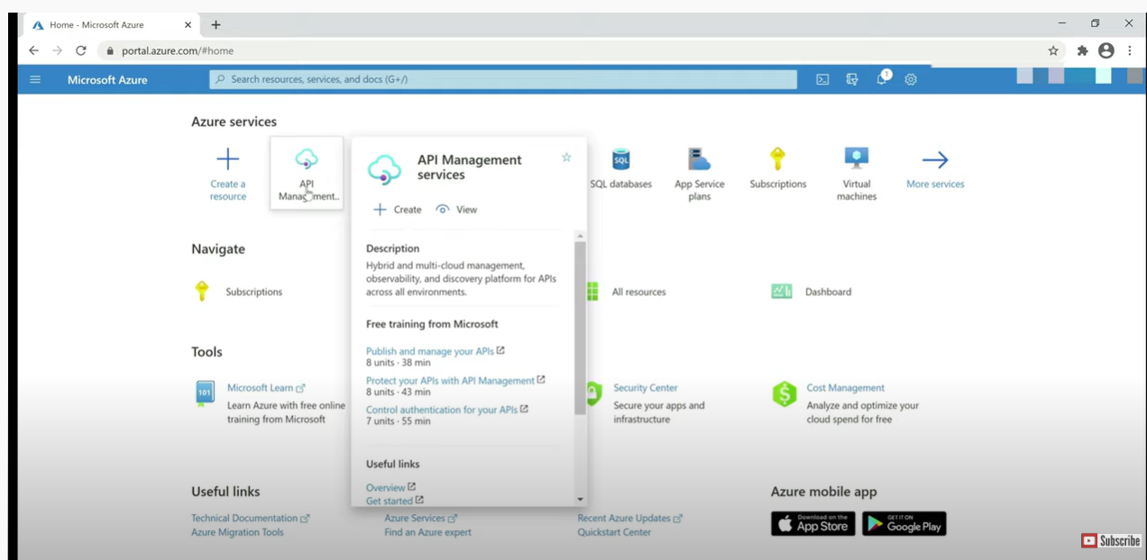

1. **We can see many options there like subscription , Resource group, Instances details we Regions which location we are storing select that location, resource name need to give resource name and organization name and administrator portal and last pricing tier**

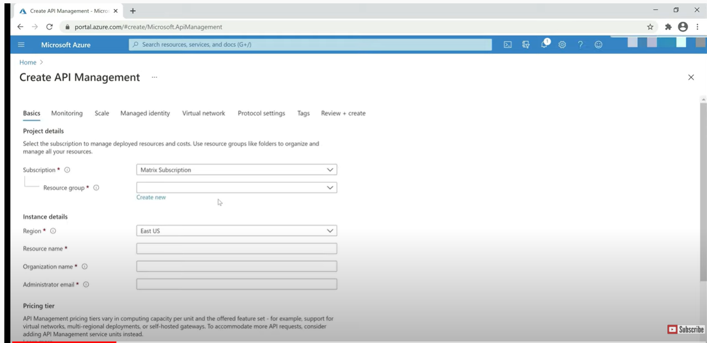

**In api basically having 3 portals**

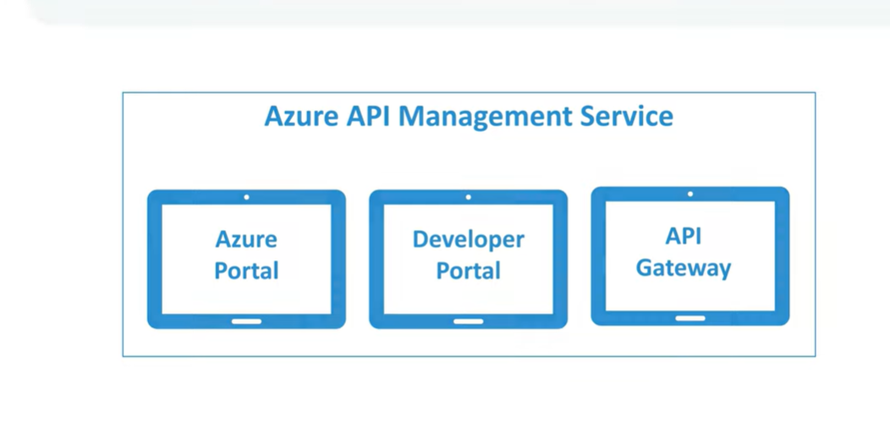

**Url looks like for both as below: In instant of name it will come our api name**

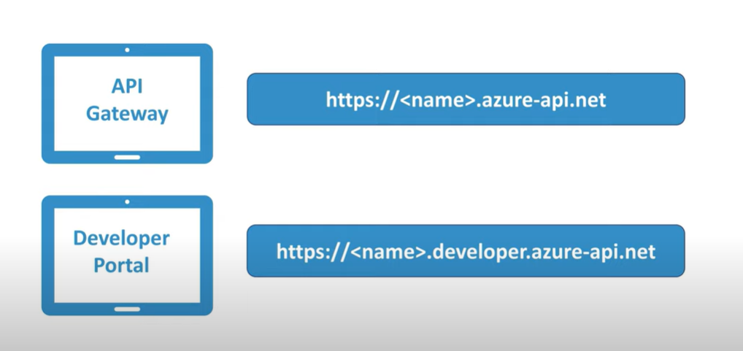

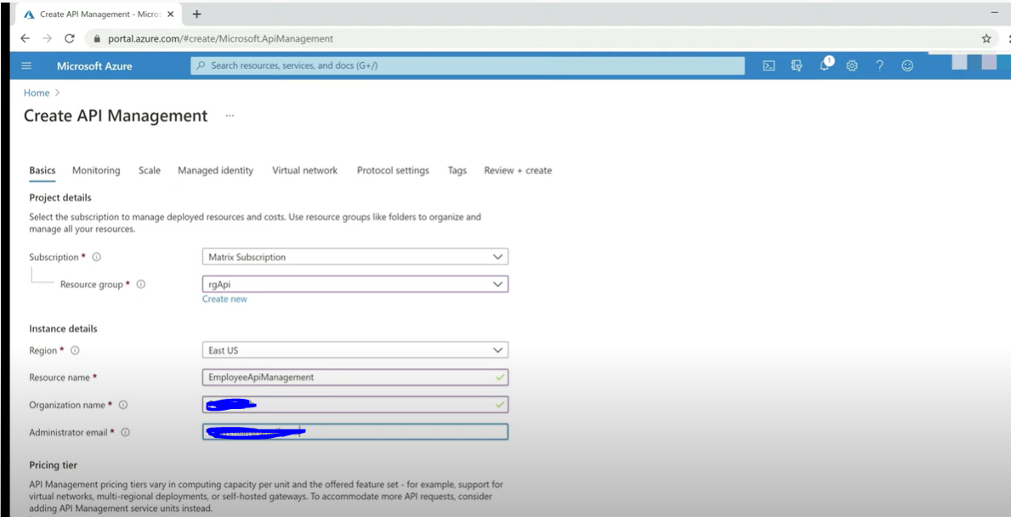

**In pricing tier**

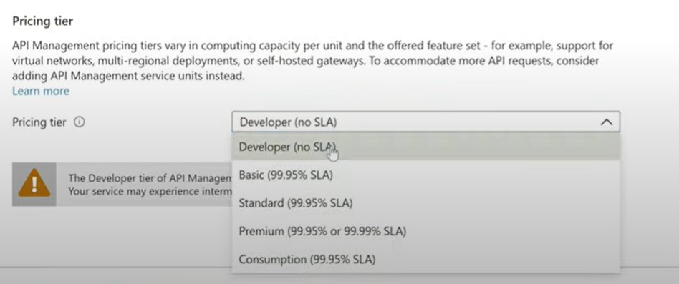

**Click on Review + create**

**After that we can see validation passed again click on create button**

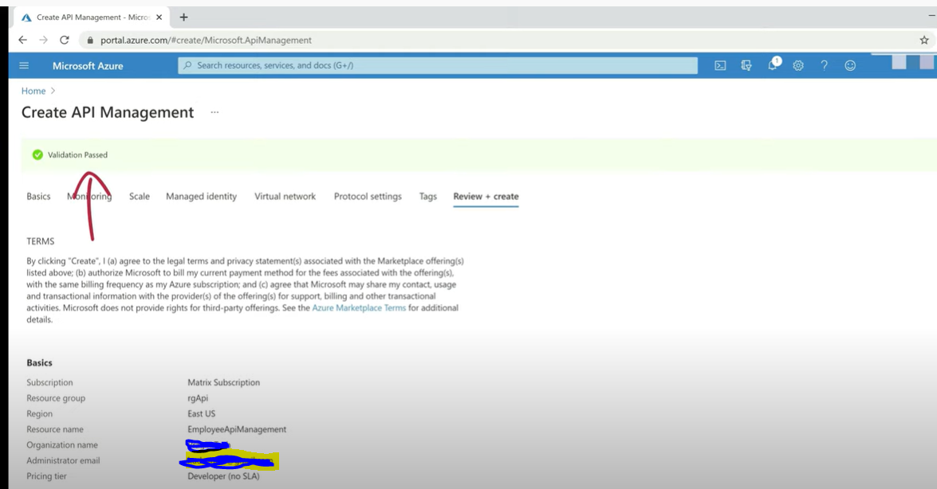

**After created successfully in api management we can see it is created**

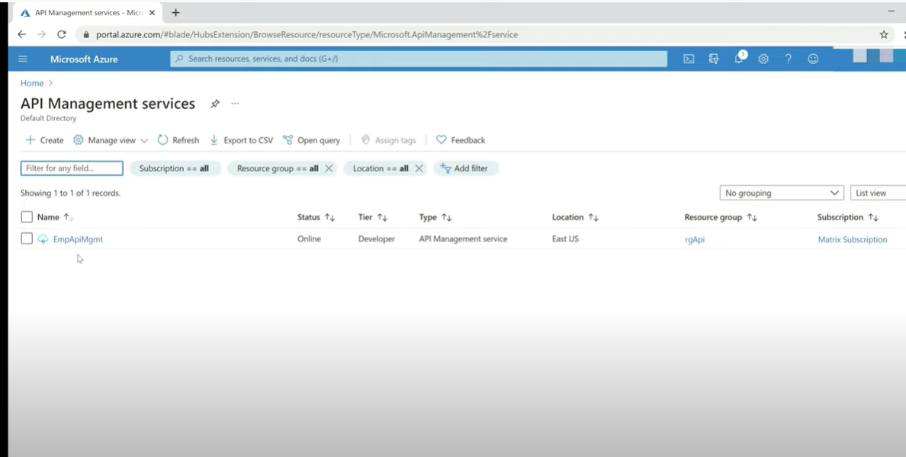

If we click on EmpApiMgmt : we can see on overview and developer portal url & Getway Url with Api name which is EmpApiMgmt and API Left side menu

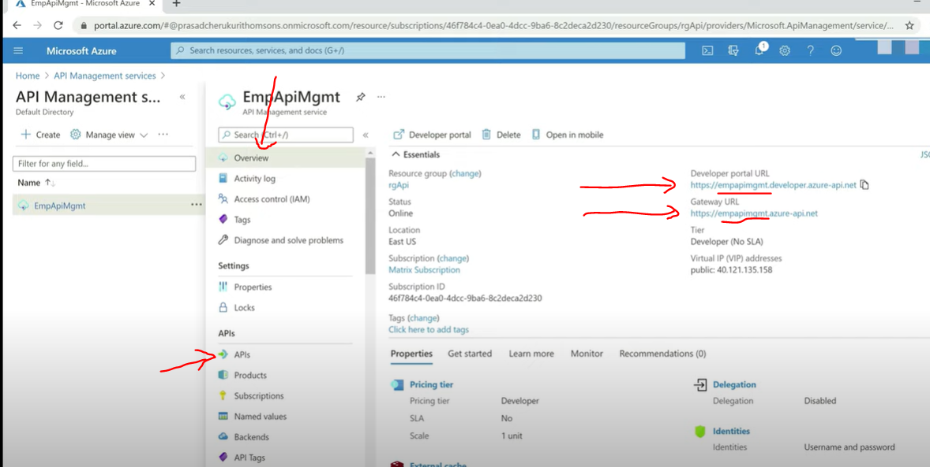

**After click on API we can see this Developer portal in which Add API**

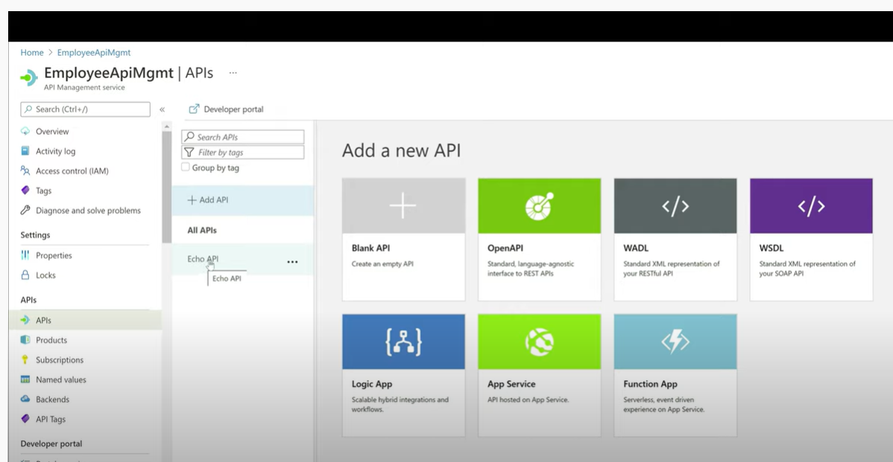

**Blank API**

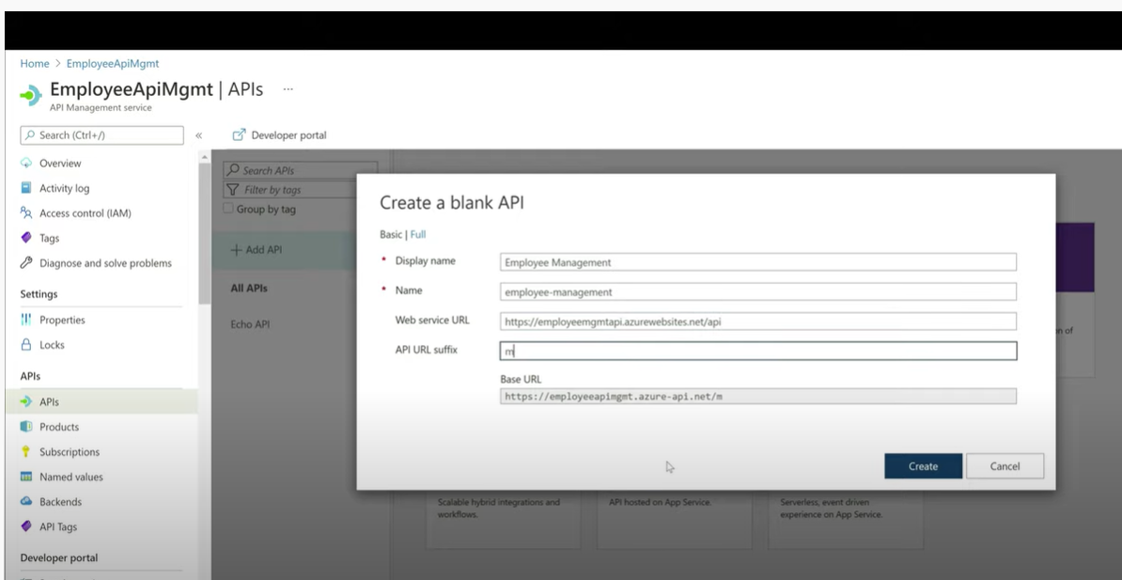

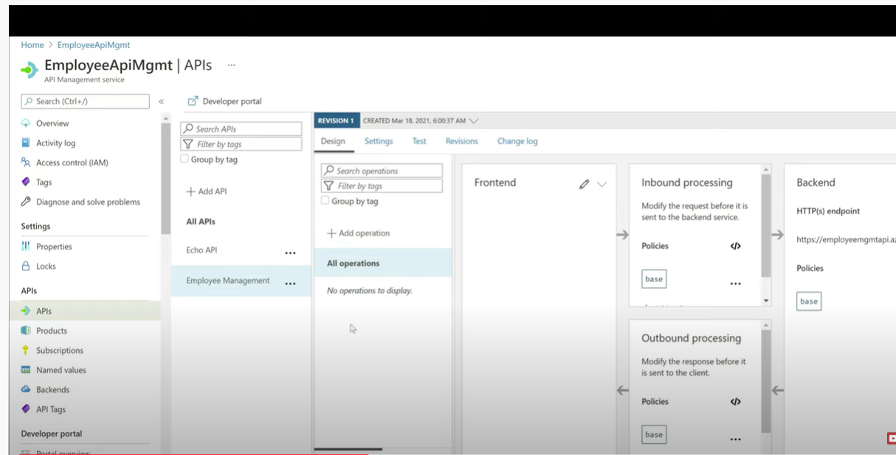

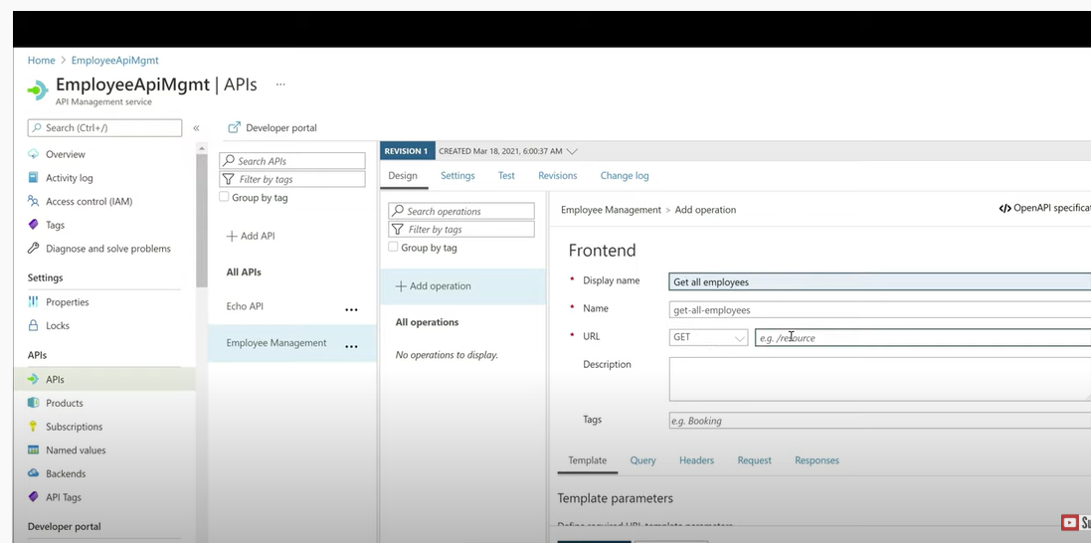

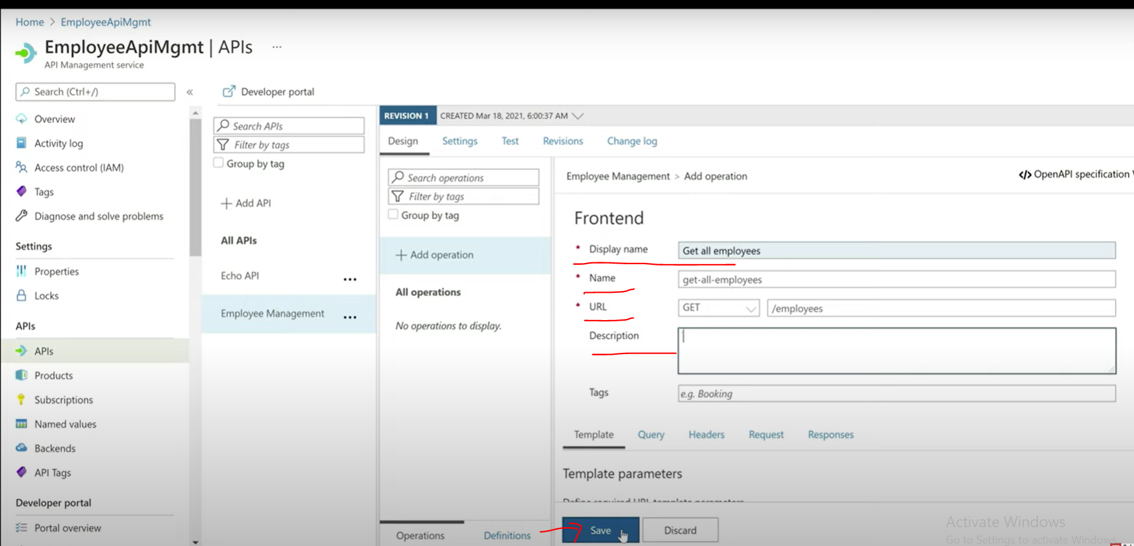

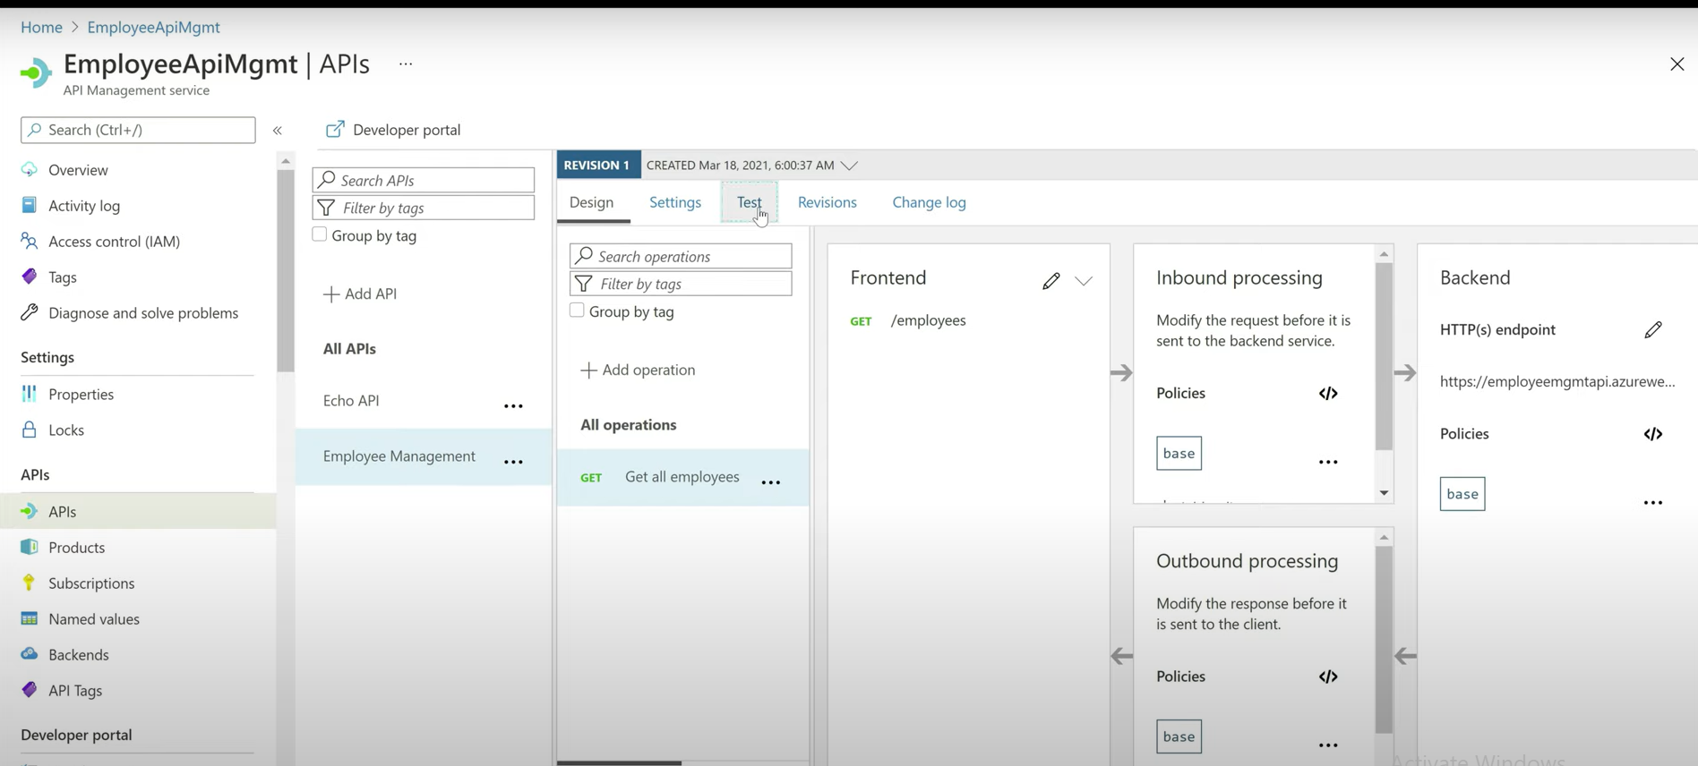

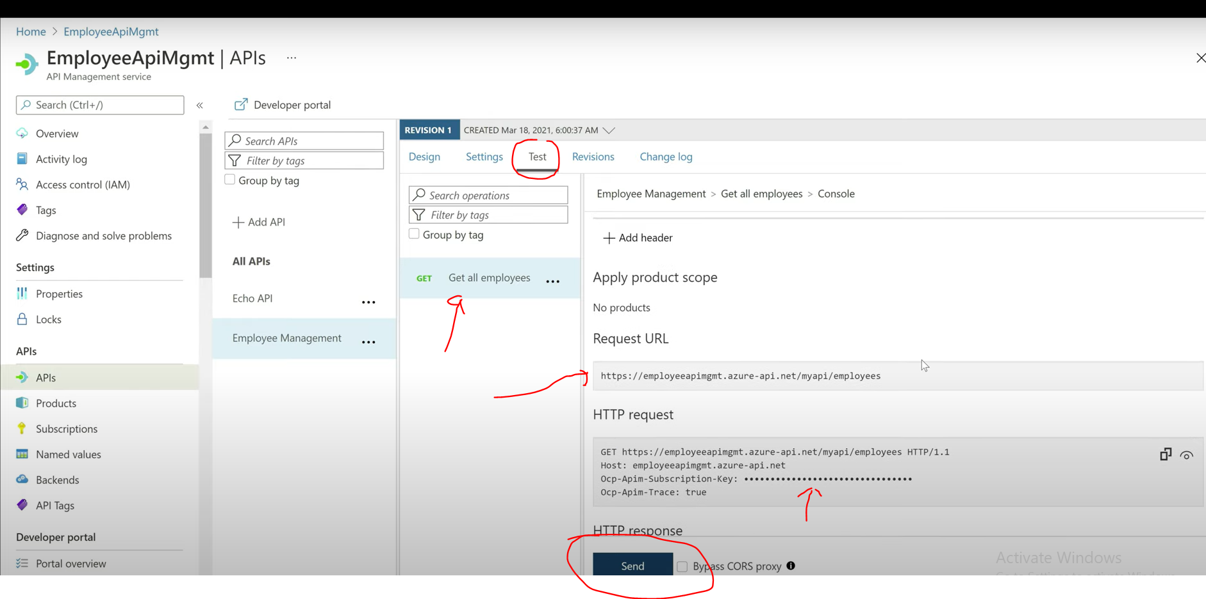

1. **Open API specification**

